Assignment No. 01
Title: A. Create Binary tree and perform following operations:
a. Insert
b. Display
c. Find Depth of a tree
d. Display leaf-nodes
e. Create a copy of a tree.
B. Implement binary search tree and perform following operations:
a. Insert b. Delete c. Display d. Search e. BFS (Level wise print)
Objective:
This assignment aims to demonstrate a practical understanding of non-linear data structures by performing fundamental operations such as searching, copying, and measuring tree depth. It focuses on differentiating between standard binary trees and ordered search trees while optimizing data retrieval and memory management.

Theory:
- Tree Data Structure
A Tree is a non-linear, hierarchical data structure consisting of a collection of nodes connected by edges. Unlike arrays or linked lists, which are linear (elements follow one after another), trees represent relationships like a family tree or a file directory system.
- Recursive Nature: A tree is composed of a root node, and every node can be the root of its own subtree.
- Properties: A tree with n nodes will always have exactly n-1 edges. There are no loops or cycles in a tree.

- Binary Tree vs. Binary Search Tree (BST)
1. Binary Tree (BT)
A Binary Tree is the simplest form of a tree where each node has at most two children (0, 1, or 2). There is no specific order in how data is arranged. If you insert "10" and then "5", "5" could go anywhere as long as it's a child of an existing node.

2. Binary Search Tree (BST)
A Binary Search Tree is a "sorted" binary tree. It follows a specific relative ordering:
- Left Subtree: All values are less than the parent node.
- Right Subtree: All values are greater than the parent node.
- No Duplicates: Typically, BSTs do not allow duplicate values (though some variations do).

Comparison Table

Feature | Binary Tree (BT) | Binary Search Tree (BST)
Ordering | No specific order for nodes. | Left < Root < Right.
Search Time | O(n) (Must check every node). | O(\log n) (On average).
Efficiency | Simple to build but slow to query. | Highly efficient for searching and sorting.
Usage | Expression trees, Huffman coding. | Database indexing, search engines.

- Tree Traversals
Traversal refers to the process of visiting every node in the tree exactly once. Because trees are non-linear, we have two main strategies: Depth-First Search (DFS) and Breadth-First Search (BFS).
A. Depth-First Search (DFS)
DFS dives deep into a branch before backtracking. There are three standard ways to do this:
- In-Order (Left, Root, Right): * Result in BST: Gives you the values in ascending sorted order.
- Pre-Order (Root, Left, Right): * Usage: Best for creating a copy of the tree or evaluating prefix expressions.
- Post-Order (Left, Right, Root): * Usage: Best for deleting a tree (bottom-up) or calculating the size of a directory.
B. Breadth-First Search (BFS) / Level-Order
BFS visits nodes level-by-level, starting from the root (Level 0), then all nodes at Level 1, and so on.
- Mechanism: It uses a Queue (First-In-First-Out). You "enqueue" the root, then repeatedly "dequeue" a node, visit it, and "enqueue" its left and right children.
- Usage: Finding the shortest path between two nodes or printing the tree exactly as it looks visually.

Pseudocodes:
1. Creating a Node
Structure Node:
Data: Value
Left: Pointer to Node (NULL)
Right: Pointer to Node (NULL)

Function CreateNode(value):
NewNode = Allocate memory for Node
NewNode.Data = value
NewNode.Left = NULL
NewNode.Right = NULL
Return NewNode

2. Inserting a Node in tree
Function InsertBST(Root, value):
If Root is NULL:
Return CreateNode(value)
If value < Root.Data:
Root.Left = InsertBST(Root.Left, value)
Else if value > Root.Data:
Root.Right = InsertBST(Root.Right, value)
Return Root

3. Searching for a Node (for BST)
Function SearchBST(Root, key):
If Root is NULL or Root.Data == key:
Return Root

If key < Root.Data:
Return SearchBST(Root.Left, key)
Else:
Return SearchBST(Root.Right, key)

4. Deleting a Node
Function DeleteBST(Root, key):
If Root is NULL:
Return NULL
If key < Root.Data:
Root.Left = DeleteBST(Root.Left, key)
Else if key > Root.Data:
Root.Right = DeleteBST(Root.Right, key)
Else: // Found the node to delete
// Case 1 & 2: One child or No child
If Root.Left is NULL:
Return Root.Right
If Root.Right is NULL:
Return Root.Left
// Case 3: Two children
Temp = FindMin(Root.Right) // Find In-order Successor
Root.Data = Temp.Data
Root.Right = DeleteBST(Root.Right, Temp.Data)
Return Root

5. Traversals
a. InOrder:
Function InOrder(Root):
If Root is not NULL:
InOrder(Root.Left)
Print Root.Data
InOrder(Root.Right)
b. PreOrder:
Function PreOrder(Root):
If Root is not NULL:
Print Root.Data
PreOrder(Root.Left)
PreOrder(Root.Right)
c. PostOrder:
Function PostOrder(Root):
If Root is not NULL:
PreOrder(Root.Left)
PreOrder(Root.Right)
Print Root.Data
d. LevelOrder: (BFS)
Function BFS(Root):
If Root is NULL:
Return
//Create an Empty Queue Q
Enqueue(Q, Root)

While Q is not empty:
Current = Dequeue(Q)
Print Current.Data
If Current.Left is not NULL:
Enqueue(Q, Current.Left)
If Current.Right is not NULL:
Enqueue(Q, Current.Right)

6. Calculating Depth of Tree
Function GetDepth(Root):
If Root is NULL:
Return 0
LeftDepth = GetDepth(Root.Left)
RightDepth = GetDepth(Root.Right)
Return Max(LeftDepth, RightDepth) + 1

7. Displaying Leaf Nodes
Function DisplayLeaf(Root):
If Root is NULL:
Return
If Root.Left is NULL and Root.Right is NULL:
Print Root.Data
DisplayLeaf(Root.Left)
DisplayLeaf(Root.Right)

8. Copy Tree
Function CopyTree(Root):
If Root is NULL:
Return NULL
NewNode = CreateNode(Root.Data)
NewNode.Left = CopyTree(Root.Left)
NewNode.Right = CopyTree(Root.Right)
Return NewNode

Flowcharts:
Fig 1.1 – Binary Tree Operations
1. Insert Node
2. Display
3. Depth of Tree
4. Display Leaf Nodes
5. Create Copy Of Tree

Fig 1.2 – Binary Search Tree Operations
a. Insert
b. Search
c. Delete
d. Display
e. BFS (Level wise print)

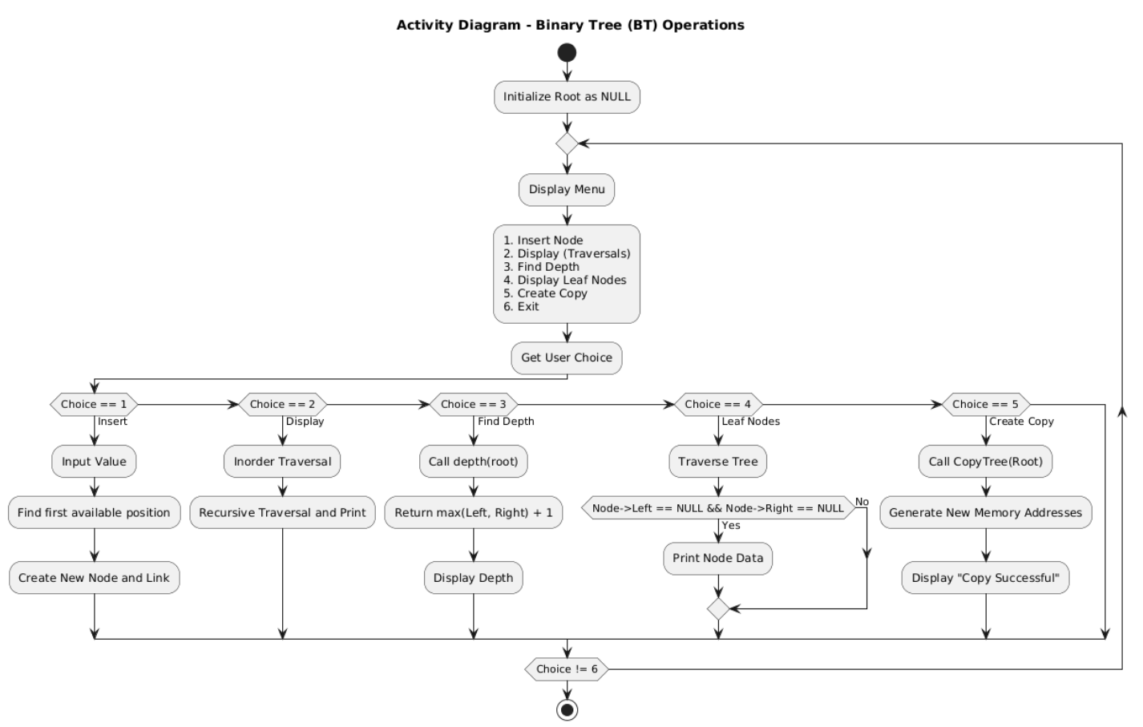
Fig 1.1 – Binary Tree Operations

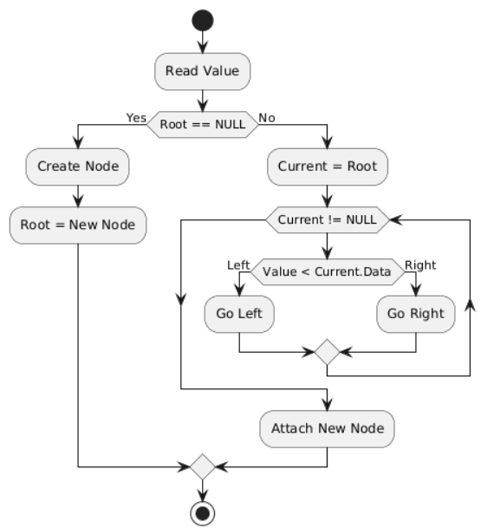

Fig 1.2.a – BST Insertion
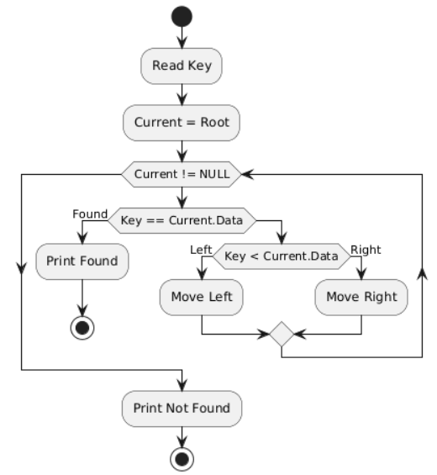
Fig 1.2.b – Search

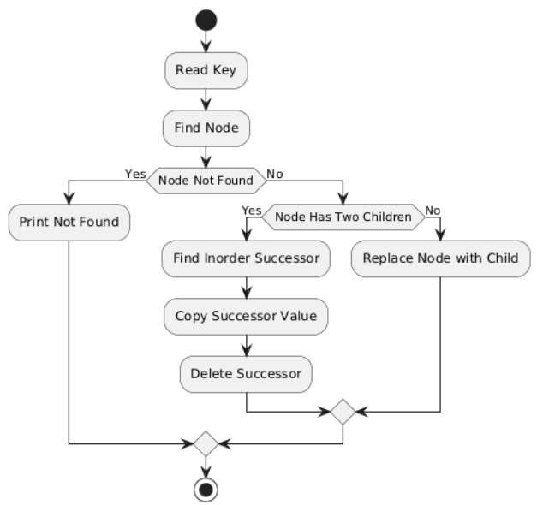
Fig 1.2.c – Delete

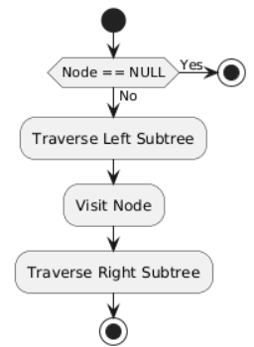
Fig 1.2.d – Display
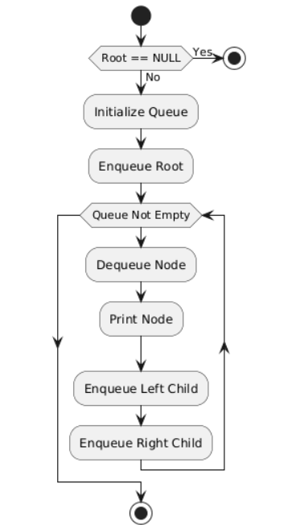
Fig 1.2.e – Level Order (BFS)

Codes:
1. BinaryTree.cpp
#include <iostream>
using namespace std;

struct Node{
int data;
Node* left;
Node* right;

};

Node* createNode(int data){
Node* newNode = new Node();
newNode->data = data;
newNode->left = nullptr;
newNode->right = nullptr;
return newNode;
}

Node* insert(Node* root, int data){
if(root == nullptr){
return createNode(data);
}
if(data < root->data){
root->left = insert(root->left,data);
}else{
root->right=insert(root->right,data);
}
return root;
}

void display(Node* root){
if(root==nullptr){
return;
}
display(root->left);
cout<<root->data<<" ";
display(root->right);
}

int height(Node* root){
if(root==nullptr){
return 0;
}
int leftH = height(root->left);
int rightH = height(root->right);
return max(leftH,rightH)+1;
}

Node* displayLeafNode(Node* root){
if(root==nullptr){
return nullptr;
}
if(root->left==nullptr && root->right==nullptr){
cout<<root->data<<" ";
}
displayLeafNode(root->left);
displayLeafNode(root->right);
return root;
}

Node* copyTree(Node* root){
if(root==nullptr){
return nullptr;
}
Node* newNode = createNode(root->data);
newNode->left = copyTree(root->left);
newNode->right = copyTree(root->right);
return newNode;
}

int main(){
Node* root = nullptr;
Node* newTree = nullptr;
root = insert(root,50);
int choice, data;
while(true){
cout<<"Menu:"<<endl;
cout<<"1. Insert"<<endl;
cout<<"2. Display - Inorder"<<endl;
cout<<"3. Height"<<endl;
cout<<"4. Display Leaf Nodes"<<endl;
cout<<"5. Copy Tree"<<endl;
cout<<"6. Exit"<<endl;
cout<<"Enter your choice: ";
cin>>choice;
switch(choice){
case 1:
cout<<"\nEnter data to insert : ";
cin>>data;
root = insert(root,data);
break;
case 2:
cout<<"\nDisplay Tree: (Inorder) ";
display(root);
cout<<endl;
break;
case 3:
cout<<"\nHeight of Tree : "<<height(root)<<endl;
break;
case 4:
cout<<"\nDisplaying Leaf Nodes: ";
displayLeafNode(root);
cout<<endl;
break;
case 5:
newTree = copyTree(root);
cout<<"\nCopied Tree: ";
display(newTree);
cout<<endl;
break;
case 6:
cout<<"\nExiting..."<<endl;
return 0;
default:
cout<<"\nInvalid Choice!"<<endl;
break;
}
}
return 0;
}

2. BinarySearchTree.cpp
#include<iostream>
#include<queue>
using namespace std;

struct Node{
int data;
Node* l;
Node* r;
};

Node* create(int data){
Node* root=new Node();
root->data=data;
root->l=NULL;
root->r=NULL;
return root;
}

void display(Node* root){
if(root==NULL){
return;
}
display(root->l);
cout<<root->data<<" ";
display(root->r);
}

Node* insert(Node* root, int data){
if(root==NULL){
return create(data);
}
if(data>=root->data){
root->r=insert(root->r,data);
}else{
root->l=insert(root->l,data);
}
return root;
}

Node* minimum(Node* root){
while(root&&root->l!=NULL){
root=root->l;
}
return root;
}

Node* del(Node* root, int data){
if(root==NULL){
return root;
}
if(data<root->data){
root->l=del(root->l,data);
}else if(data>root->data){
root->r=del(root->r,data);
}else{
if(root->l==NULL){
Node* t=root->r;
delete root;
return t;
}else if(root->r==NULL){
Node* t=root->l;
delete root;
return t;
}else{
Node* t=minimum(root->r);
root->data=t->data;
root->r=del(root->r,t->data);
}
return root;
}
}

int search(Node* root, int val){
if(root==NULL){
cout<<"Value not found"<<endl;
return 0;
}
if(root->data==val){
cout<<"Value found"<<endl;
}else if(val<root->data){
search(root->l,val);
}
else{
search(root->r,val);
}
}

void bfs(Node* root) {
if(root==NULL) {
return;
}
queue<Node*> q;
q.push(root);
while (!q.empty()) {
Node* temp=q.front();
q.pop();
cout<<temp->data<<" ";
if(temp->l!=NULL){
q.push(temp->l);
}
if (temp->r != NULL){
q.push(temp->r);
}
}
}

int main(){
Node* root=NULL;
int ch, val;
while(true){
cout<<"Menu:"<<endl;
cout<<"1. Insert"<<endl;
cout<<"2. Display"<<endl;
cout<<"3. Delete"<<endl;
cout<<"4. Search"<<endl;
cout<<"5. BFS"<<endl;
cout<<"6. Exit"<<endl;
cout<<"Enter your choice: ";
cin>>ch;
switch(ch){
case 1:
cout<<"Enter data to insert:";
cin>>val;
root=insert(root,val);
cout<<"Node inserted in tree"<<endl;
break;
case 2:
cout<<"Inorder Tree: ";
display(root);
cout<<endl;
break;
case 3:
cout<<"Which value to delete?"<<endl;
cin>>val;
root=del(root,val);
cout<<"Node deleted"<<endl;
break;
case 4:
cout<<"Which value to search?"<<endl;
cin>>val;
search(root,val);
break;
case 5:
cout<<"BFS Traversal: "<<endl;
bfs(root);
cout<<endl;
break;
case 6:
cout<<"BYE BYE User!"<<endl;
return 0;
default:
cout<<"Invalid Choice!"<<endl;
break;
}
}
return 0;
}

Outputs:
1. Binary Tree
a. Insertion
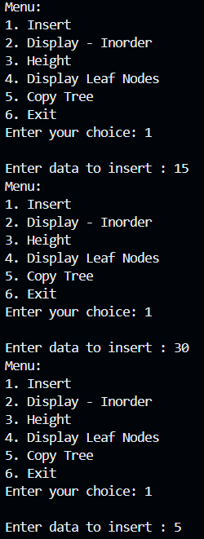
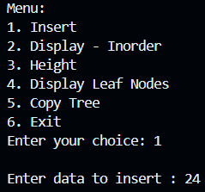
b. Display
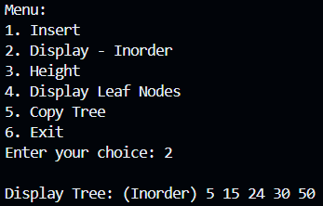

c. Height
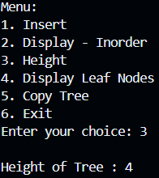

d. Leaf Nodes
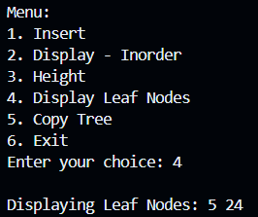

e. Copy Tree
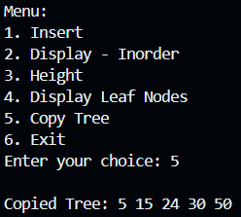

2. Binary Search Tree
a. Insertion
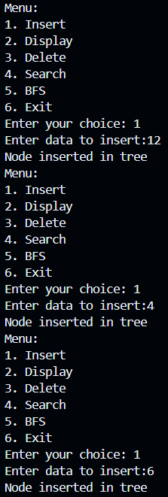
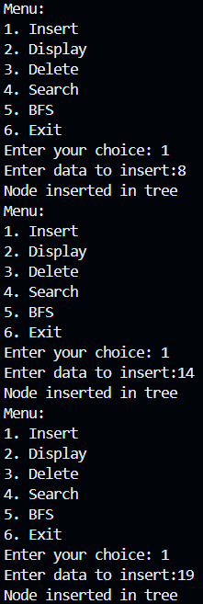
b. Display
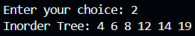
c. Delete
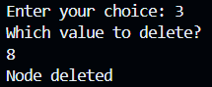

d. Search
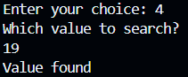

e. BFS
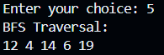

Conclusion:
In this assignment, I’ve studied about Binary Trees and Binary Search Trees and implemented all the important operations of them using C++. With this practical demonstration I’ve gained enough knowledge of the Tree Data Structure.

